SESSION 16: R FOR BUSINESS ANALYTICS (CONTD.)

Assignment 1

1. Introduction .......................................................................................................................................... 3

2. Objective ............................................................................................................................................... 3

3. Prerequisites ......................................................................................................................................... 3

4. Associated Data Files ............................................................................................................................ 3

5. Problem Statement ............................................................................................................................... 3

6. Expected Output ................................................................................................................................... 3

7. Approximate Time to Complete Task ................................................................................................... 3

**1. Introduction**

This assignment will help you understand the concepts learnt in the session.

**2. Objective**

To understand the concepts in R.

**3. Prerequisites**

Not applicable.

**4. Associated Data Files**

N/A

**5. Problem Statement**

• Write a function that to calculate BMI (Body Mass Index):

• BMI for a person is defined as their body mass divided by the square of their height

• The weight is in kilograms and the height in meters or

• (The weight can be in pounds and the height in inches)* 703

• Check your BMI:



Please find the screen shot for query written and result.

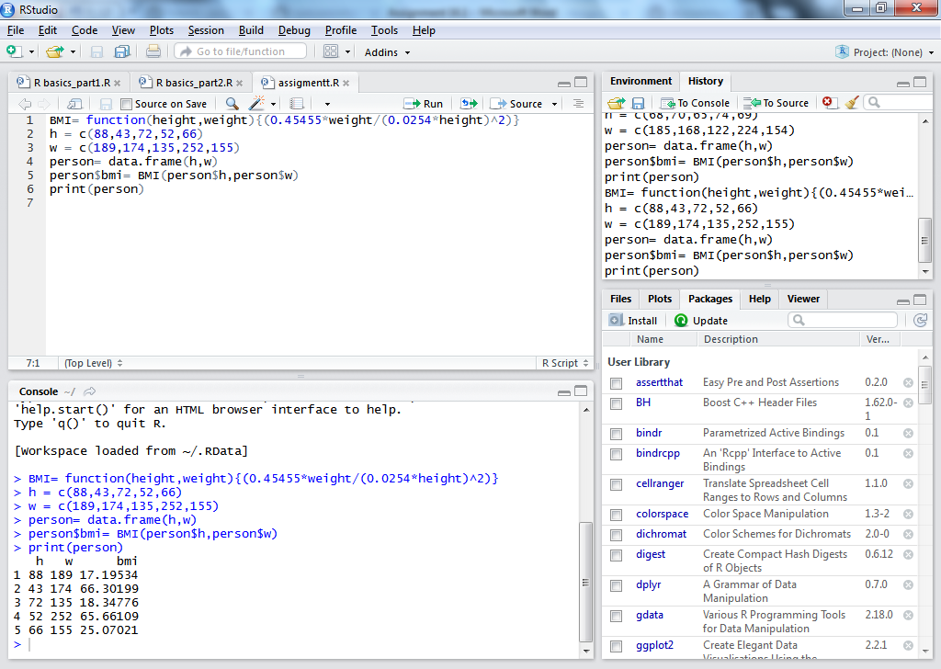

So As per the result that come, it found that one person is underweight, one has normal weight , one of them is over weight and two of them is very severely obese.